**Team Assignment: Clustering Colleges and Universities**

Colleges and universities are often interested in identifying their peer institutions. The file attached contains 300+ academic institutions with a number of (rather artificial) metrics. Good enough for this exercise

Use cluster analysis to explore and analyze the given dataset as follows:

1. Use the variables to cluster the institutions (hint: remember normalization)

**NOTE: In order to have a uniform criterion for comparison and although you can run several algorithms and test them with different number of clusters, I would like you to focus on 4 clusters**

1. How many schools are in each cluster? What are the cluster centers (mean values of each metric). Hint: look at the clusters view once you run the cluster analysis

Cluster 1 comprises 42% of the data with 129 schools in the cluster.

Cluster 2 comprises 22.8% of the data with 70 schools in the cluster.

Cluster 3 comprises 20.2% of the data with 62 schools in the cluster.

Cluster 4 comprises 15% of the data with 46 schools in the cluster.

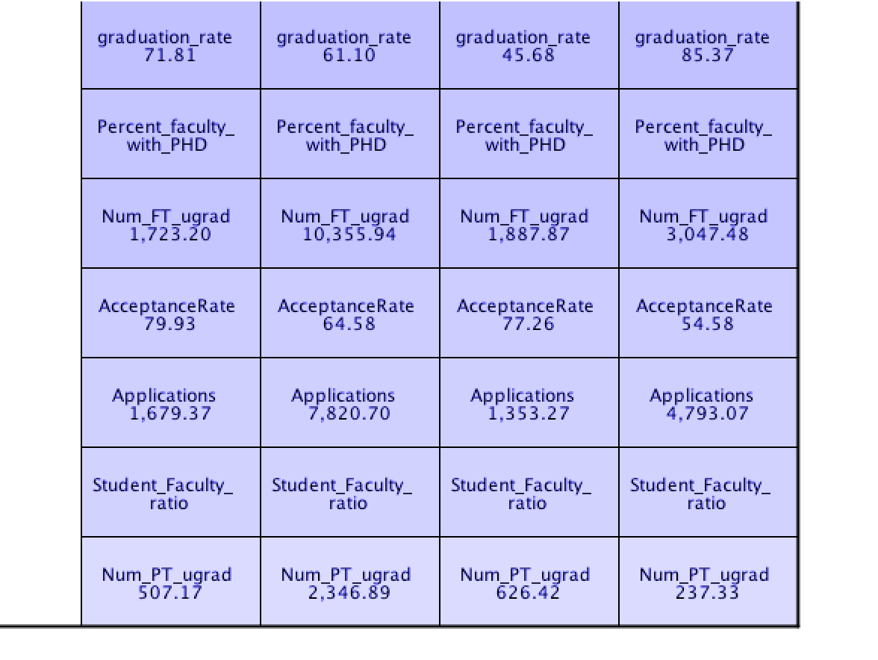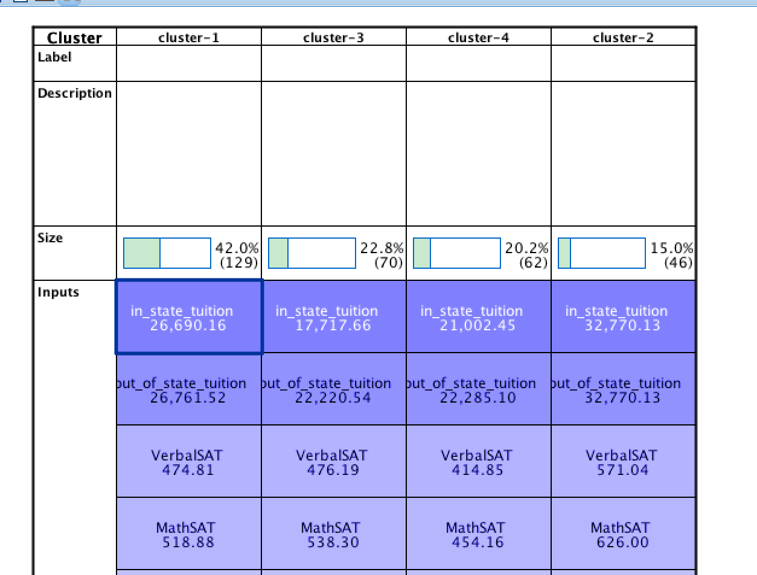

1. How would you characterize each of the clusters based on those mean metrics?

